Assignment 2 Python programming
Name :- Pankaj kumar
TASK 1: Student Information System (Basics)
Problem
Design a class Student that stores:
• Name
• Roll number
Provide:
• A constructor to initialize values
• A method to display student details
Create at least 2 student objects and display their details.
class Student:
def __init__(self, name, roll_number):
self.name = name
self.roll_number = roll_number
def display_details(self):
print("Student Name:", self.name)
print("Roll Number:", self.roll_number)
student1 = Student("Pankaj", 101)
student2 = Student("Kapil", 102)
student1.display_details()
student2.display_details()
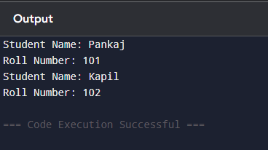
Q2:- Rectangle Calculator (Constructor + Methods)
class Rectangle:
def __init__(self, length, width):
self.length = length
self.width = width
def calculate_area(self):
return self.length * self.width

def calculate_perimeter(self):
return 2 * (self.length + self.width)
length = float(input("Enter length: "))
width = float(input("Enter width: "))
rect = Rectangle(length, width)
print("Area of Rectangle:", rect.calculate_area())
print("Perimeter of Rectangle:", rect.calculate_perimeter())
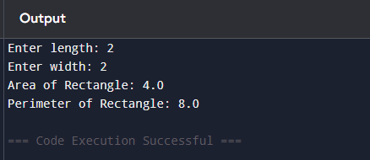
Q-3 Bank Account System (Encapsulation)
class BankAccount:
def __init__(self, balance=0):
self.__balance = balance
def __display_balance(self):
print("Current Balance:", self.__balance)
def deposit(self, amount):
if amount <= 0:
print("Invalid deposit amount! Amount must be positive.")
else:
self.__balance += amount
print(f"Deposited: {amount}")
self.__display_balance()
def withdraw(self, amount):
if amount <= 0:
print("Invalid withdrawal amount!")
elif amount > self.__balance:
print("Insufficient balance! Withdrawal denied.")
else:
self.__balance -= amount
print(f"Withdrawn: {amount}")
self.__display_balance()
def show_balance(self):
self.__display_balance()
acc = BankAccount(1000)
acc.show_balance()
acc.deposit(500)
acc.withdraw(200)
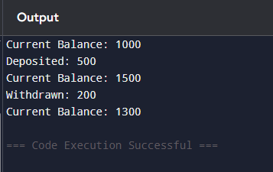

Q :- 4 Employee Salary System (Inheritance)
class Employee:
def __init__(self, name, base_salary):
self.name = name
self.base_salary = base_salary
def calculate_salary(self):
return self.base_salary
class Developer(Employee):
def __init__(self, name, base_salary, coding_bonus):
super().__init__(name, base_salary)
self.coding_bonus = coding_bonus
def calculate_salary(self):
return self.base_salary + self.coding_bonus
class Manager(Employee):
def __init__(self, name, base_salary, management_bonus):
super().__init__(name, base_salary)
self.management_bonus = management_bonus
def calculate_salary(self):
return self.base_salary + self.management_bonus
dev = Developer("Pankaj", 50000, 10000)
mgr = Manager("Kapil", 70000, 20000)
print("Developer Salary:", dev.calculate_salary())
print("Manager Salary:", mgr.calculate_salary())
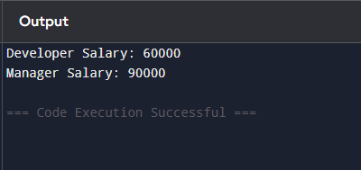
Q:-5 Multilevel Banking System
class Account:
def __init__(self, balance):
self.__balance = balance
def _get_balance(self):
return self.__balance
def _set_balance(self, amount):
self.__balance = amount
class DepositAccount(Account):
def deposit(self, amount):
if amount <= 0:
print("Invalid deposit amount!")
else:
new_balance = self._get_balance() + amount
self._set_balance(new_balance)
print(f"Deposited: {amount}")
class TransactionAccount(DepositAccount):
def withdraw(self, amount):
if amount <= 0:
print("Invalid withdrawal amount!")
elif amount > self._get_balance():
print("Insufficient balance!")
else:
new_balance = self._get_balance() - amount
self._set_balance(new_balance)
print(f"Withdrawn: {amount}")
def display_balance(self):
print("Current Balance:", self._get_balance())
acc = TransactionAccount(1000)
acc.display_balance()
acc.deposit(500)
acc.withdraw(300)
acc.display_balance()
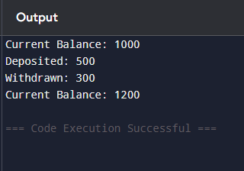

Q:-6 Shape System (Abstraction)
from abc import ABC, abstractmethod
class Shape(ABC):
@abstractmethod
def area(self):
pass
class Circle(Shape):
def __init__(self, r):
self.r = r
def area(self):
return 3.14 * self.r * self.r
class Rectangle(Shape):
def __init__(self, l, w):
self.l = l
self.w = w
def area(self):
return self.l * self.w
c = Circle(5)
r = Rectangle(4, 6)
print("Circle Area:", c.area())
print("Rectangle Area:", r.area())
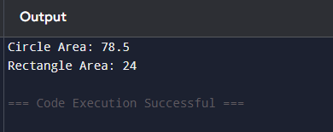
Q7:- User Login System (Encapsulation + Abstraction)
class User:
def __init__(self, username, password):
self.username = username
self.__password = password # private attribute
def __verify_password(self, password):
return self.__password == password
def login(self):
pwd = input("Enter password: ")
if self.__verify_password(pwd):
print("Login Successful!")
else:
print("Wrong Password!")
user1 = User("Pankaj", "1234")
print("Username:", user1.username)
user1.login()
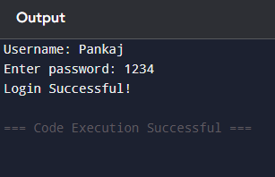
Q:-8- File Processing System (Abstraction)
class FileProcessor:
def __read_file(self, filename):
with open(filename, "r") as f:
return f.read()

def __analyze(self, data):
return len(data.split())

def process_file(self, filename):
data = self.__read_file(filename)
result = self.__analyze(data)
print("Word count:", result)

fp = FileProcessor()
fp.process_file("file.txt")

Output:
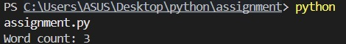

Q 9:- Payment System (Polymorphism)

class Payment:
def pay(self, amount):
print("Payment of", amount)
class UPI(Payment):
def pay(self, amount):
print("Paid", amount, "using UPI")
class Card(Payment):
def pay(self, amount):
print("Paid", amount, "using Card")
class NetBanking(Payment):
def pay(self, amount):
print("Paid", amount, "using Net Banking")
p1 = UPI()
p2 = Card()
p3 = NetBanking()

p1.pay(1000)
p2.pay(2000)
p3.pay(3000)
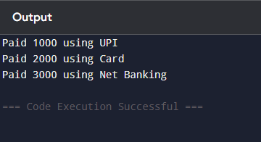

Q10:- Operator Overloading System

class Point:
def __init__(self, x, y):
self.x = x
self.y = y
def __add__(self, other):
return Point(self.x + other.x, self.y + other.y)
def __str__(self):
return f"({self.x}, {self.y})"
p1 = Point(3, 6)
p2 = Point(3, 9)
result = p1 + p2
print("Result:", result)
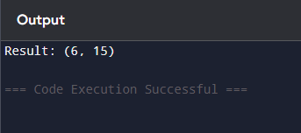
Q-11 Product Comparison System
class Product:
def __init__(self, price):
self.price = price
def __gt__(self, other):
return self.price > other.price
p1 = Product(500)
p2 = Product(800)
if p1 > p2:
print("Product 1 is costlier")
else:
print("Product 2 is costlier")

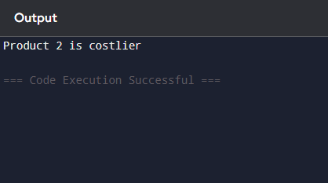
Q12- Smart Home System (Combined Concepts)
from abc import ABC, abstractmethod
class Device(ABC):
def turn_on(self):
self._on_operation()
def turn_off(self):
self._off_operation()
@abstractmethod
def _on_operation(self):
pass
@abstractmethod
def _off_operation(self):
pass
class Light(Device):
def _on_operation(self):
print("Light is ON 💡")
def _off_operation(self):
print("Light is OFF ❌")
class Fan(Device):
def _on_operation(self):
print("Fan is ON 🌀")
def _off_operation(self):
print("Fan is OFF ❌")
class AC(Device):
def _on_operation(self):
print("AC is ON ❄️")

def _off_operation(self):
print("AC is OFF ❌")
light = Light()
fan = Fan()
ac = AC()
while True:
choice = int(input("Enter choice: "))

if choice == 1:
light.turn_on()
elif choice == 2:
light.turn_off()
elif choice == 3:
fan.turn_on()
elif choice == 4:
fan.turn_off()
elif choice == 5:
ac.turn_on()
elif choice == 6:
ac.turn_off()
elif choice == 7:
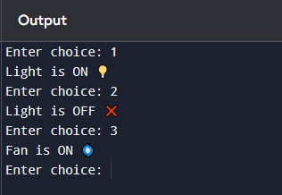
Q13:- Library Management System (Mini Project)
class Library:
def __init__(self):
self.__books = []
def add_book(self, book_name):
self.__books.append(book_name)
print(f"Book '{book_name}' added successfully.")
def show_books(self):
if len(self.__books) == 0:
print("No books in library.")
else:
print("Available Books:")
for book in self.__books:
print("-", book)
def issue_book(self, book_name):
if book_name in self.__books:
self.__books.append(book_name)
print(f"Book '{book_name}' issued successfully.")
else:
print("Book not available.")
def return_book(self, book_name):
self.__books.remove(book_name)
print(f"Book '{book_name}' returned successfully.")
lib = Library()
while True:
choice = int(input("Enter your choice: "))

if choice == 1:
book = input("Enter book name: ")
lib.add_book(book)
elif choice == 2:
lib.show_books()
elif choice == 3:
book = input("Enter book name to issue: ")
lib.issue_book(book)
elif choice == 4:
book = input("Enter book name to return: ")
lib.return_book(book)
elif choice == 5:
print("Thank you!")
break
else:
print("Invalid choice!")
print("Exiting...")
break
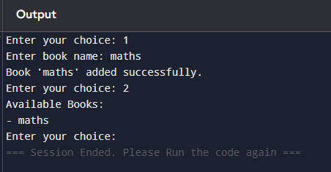
Q14:- Log Analyzer Tool (Real-World)

Q15:- ATM Simulation (Final Integrated Task)
class Account:
def __init__(self, balance, pin):
self.__balance = balance
self.__pin = pin
def check_pin(self):
p = input("Enter PIN: ")
return p == self.__pin
def deposit(self):
if self.check_pin():
amt = int(input("Enter amount: "))
self.__balance += amt
print("Deposited!")
else:
print("Wrong PIN")
def withdraw(self):
if self.check_pin():
amt = int(input("Enter amount: "))
if amt > self.__balance:
print("Not enough balance")
else:
self.__balance -= amt
print("Withdrawn!")
else:
print("Wrong PIN")
def show_balance(self):
if self.check_pin():
print("Balance:", self.__balance)
else:
print("Wrong PIN")
acc = Account(1000, "1234")
while True:
print("\n1.Deposit 2.Withdraw 3.Balance 4.Exit")
ch = input("Enter choice: ")
if ch == "1":
acc.deposit()
elif ch == "2":
acc.withdraw()
elif ch == "3":
acc.show_balance()
elif ch == "4":
break
else:
print("Invalid")
